**PARADE USER GUIDE**

**Log Data**



**Version 1.50 Apr 2021**

**Version History**

|  |  |  |  |
| --- | --- | --- | --- |
| **Version** | **Date** | **Author** | **Comments** |
| 1.46 | Jan 2021 | K.Wilson | Original Version |
| 1.47 | Feb 2021 | K.Wilson | Added Log calculations |
| 1.50 | Apr 2021 | K.Wilson | General review |

Contents

Introduction 1

Defining log files 2

Importing log files 3

Importing data 4

Plotting log data 8

Difference between depth plots and log plots 8

Plot wizard 8

Log Plot definition 12

Plot screen 13

Filtering logs 14

Scaling plots 15

Multiple page plots 16

Log data on Depth plots 17

Manipulating data 19

The difference between sampling and filtering 19

Sampling Log data 19

Log Calculations 22

Calculation units 26

Running the calculation 26

Differential pressure calculation 27

Log Import Formats 30

Log definition templates 31

Log Calculation templates 32

# Introduction

The term “Log data” refers to any time-based or depth-based set of data that is not part of the standard set of Parade tables. Ie the input, calculated and library data.

Log data may include MWD, LWD, Wire line log files or mud logs, to name a few.

This data is usually sourced from 3rd parties and may be imported from text files. The actual delivery may be in Excel or WITSML formats. Excel itself can export to tab delimited files and the WITSML files can be read, filtered and exported to tab delimited text files within Parade.

The Log Data option in Parade provides the following functionality

* Log files can be defined, ie their name and the fields they contain.
* Data can be imported into these files from Tab-delimited text files, CSV files or files where data is aligned in columns
* A plot wizard allows a basic plot to be created easily and quickly
* Plots can be time based or depth based
* Plots can then be enhanced and modified
* Plots can be multi paged or fitted to a single page
* The plot screen allows logs files to be filtered on multiple criteria and the resulting filtered log table can be saved as a new table
* For a multiple page plot, the page start value, page size and scroll size can be defined and buttons allow scrolling through the pages.
* Templates are available for plot definitions and for import formats. A manually created definition or format can be saved to the library for reuse when a similar log file is processed
* Log data can be sampled over fixed intervals using Average, Minimum or Maximum values in each interval. Sampling creates a new log table with fewer records but retaining the general shape of the original.
* Calculations can be performed on log tables to create new fields based on a series of arithmetic calculations involving field values, constants and the result of previous calculations.
* Log calculations can be entered as a single text string and scanned to create the steps
* Log calculations can be saved as templates and these templates loaded for future calculations of the same type.
* The saved calculation templates can be viewed and corrected.

# Defining log files

The log file is defined in the log list by its file name and a description. Each file then has its fields defined.

This screen is displayed using the Definition of Log table option in the Log Data menu.

It displays 2 tables, on the left is a list of log files and on the right is the fields for the selected log table.

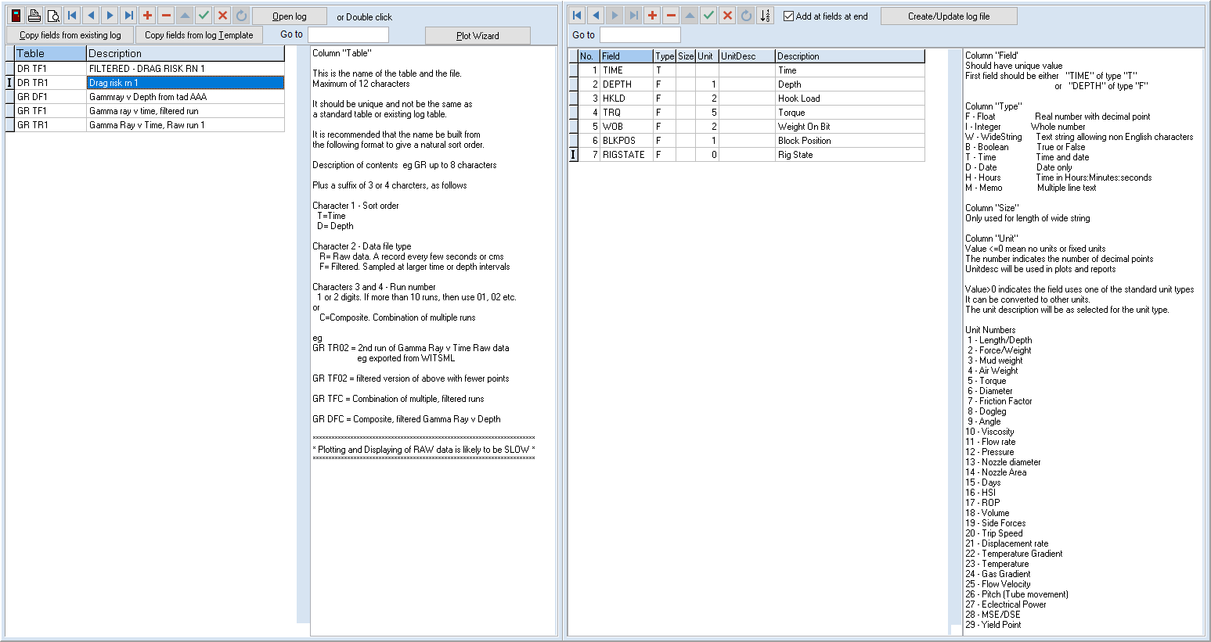

The log list consists of a log code, which is also the file name of the corresponding PXD file plus a description. It is suggested that the last 3 characters of the code follow a format, which is described on the screen, to distinguish between Time base and depth based logs, between raw data and filtered or sampled data and between different runs for the same log data.

To make it easy to create field definitions, it is possible copy the fields from an existing log file or from a definition in the library.

The fields table can be manually edited and enlarged in the right table. Each field must have a type and may have one of the standard unit types. This will be changed in display and plots to match the user selected units. Eg depth may be in feet or m, whatever the unit used in the text file that is imported. However, many log fields may not use standard unit types or have no units. In this case no conversion is done but the number of decimal places can be indicated by a negative number in the unit type and the unit description can be entered as text.

Once the fields are defined or changed, a file can be created with the matching fields, if it doesn’t exist, or its fields can be modified if it does.

The [Open log] button is used to display the actual data in the selected log table (or double click on the line)

# Importing log files

After selecting a particular file and opening it a new screen will show the current contents, if they exist.

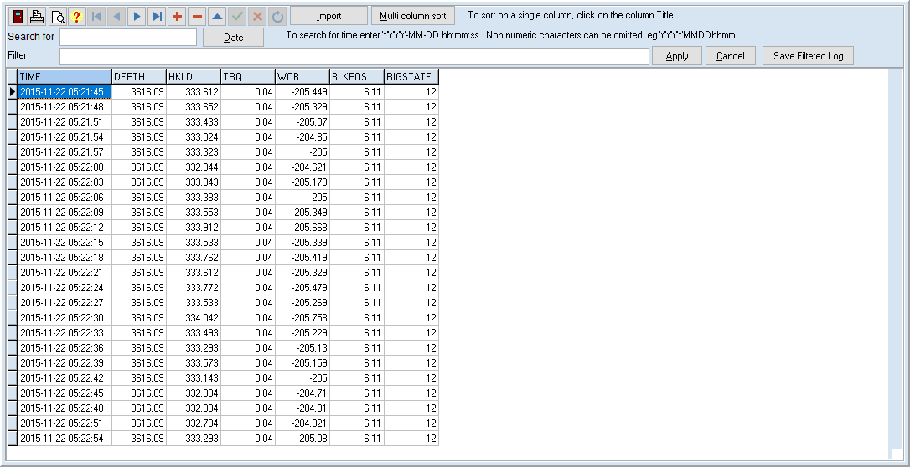

Clicking on a column header will sort the data based on that column. For sorting on more than 1 column click on the [Multi Column sort] button.

Select the sort fields in order and click [Process]

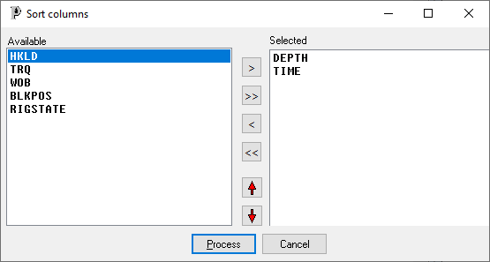

## Importing data

The import button allows data to be imported from a text file.

After clicking on [Import], a file open dialog is displayed so you can select the file to import and then the import dialog is displayed, showing the data in the file.

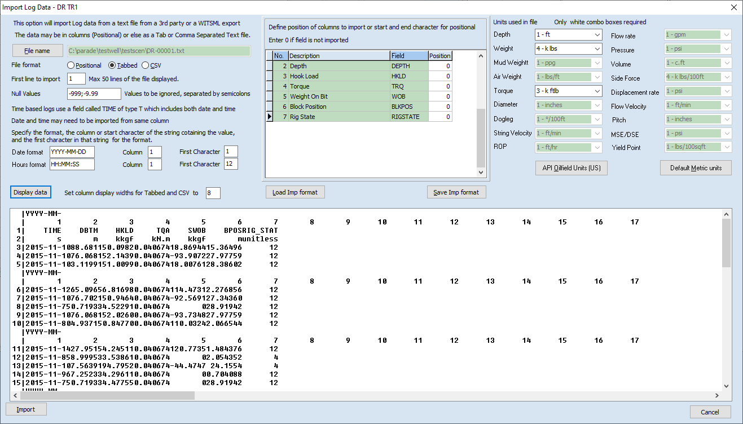

You can also change and select the file on this screen, by clicking on [File name] or entering the name into the Filename field.

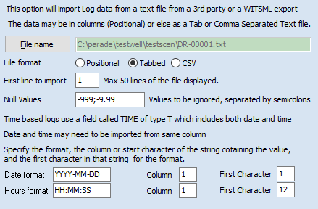

The program will determine what type of text file is being read and preselect the corresponding File format choice.

Many files will have header lines, titles etc at the start of the file so you can indicate which line in the file is the first to contain actual data.

Some companies use a specific value to indicate a null value, which is then ignored. This form allows multiple null values to be defined, separated by semi colons.

Since many of the log files will be time based you can define the format used for date and time, together with the column(s) from which they are imported. In this case, WISTML data uses a date time combination field, in which case you need to indicate the starting position for the date string, but in some files they may be in separate column. Parade uses a Time field that includes both date and hours. In YYYY-MM-DD hh:mm:ss format.

Finally, for Tab and CSV data you can indicate how wide the delimited columns should be in the preview, so that they align vertically.

The middle part of this dialog is a table that lists all the fields in the log table.

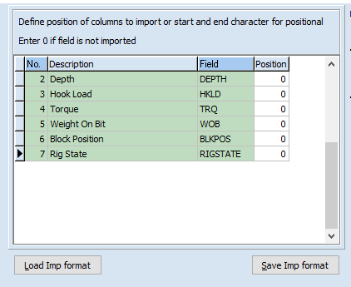

For a Tab or CSV field the column number is entered for each filed to be imported. For positional data the start and end character positions are defined.

On the right of the dialog is a list of unit types and the choices for them. Only the unit types for fields in the table are enabled (ie white) and the others are green. You select the units in the text file, which may be different from the units used in displaying data. This allows imported values to be converted to base values for storing in the file and these values can then be converted to selected units when displayed, just like the standard tables.

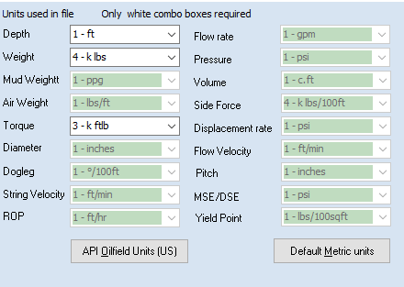

There are buttons to select API or Metric standard units.

Once you have setup the import definition for a particular sort of text file, it can be saved as an import format in the library and then loaded next time a similar file is read.

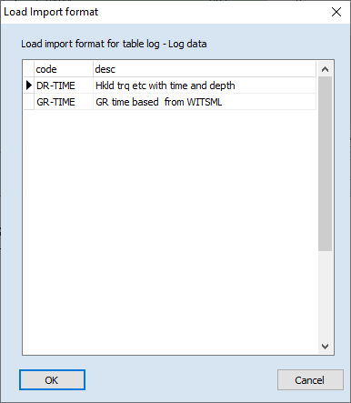

Using this option will set all the parameters to values you have previously saved

At any time you can click on [Display data] to redisplay the data, plus the selected columns for import

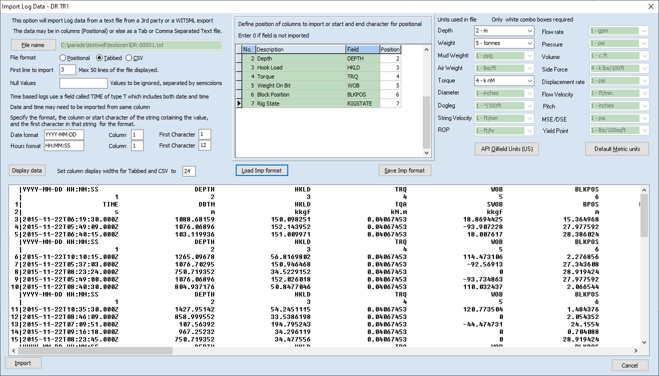

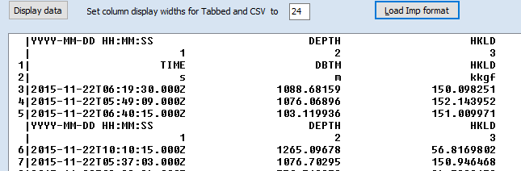

The column numbers and the field positions are indicated by 2 lines for every 5 lines of the imported file. Click on [Import] to read the text file and create the log table. This will overwrite any existing data in the table and a confirmation is required.

# Plotting log data

Log plots can be created by adding the plot header, track definitions and curve definitions manually but it is easier to use the plot wizard and then modify the result as required.

## Difference between depth plots and log plots

While a depth based Log plot may seem similar to a depth plot, there are some fundamental differences.

A Depth Plot is primarily used to display sets of calculated data with groups of 5 curves displaying the results for different risk factors.

As such each Graph of a Depth Plot only displays data from a single calculated table and only curves which use the same units. Curves from different tables or which use different units can be overlaid on top of one another if required. The data hierarchy is Plot, which may have several Graphs, which in turn have several Curves.

Log plots have a plot header and multiple curves, which may come from different log tables and use different units. Each of these is located on a particular track. So, tracks and curves, while related are defined independently. If a curve is assigned to a track that hasn’t been defined, it will not be displayed.

Log Plots may be time based as well as depth based.

Log Plots can be fitted to a single page, the same as depth plots but can also be plotted over multiple pages.

# Plot wizard

The plot wizard is launched from the log definition display screen.

It has a 3-page tabbed notebook for the 3 step definition process. Many defaults will be used to minimise data entry, eg colours and styles of the curves.

The first step is to define the plot header – code, title, type, orientation. The plot code will default to the log table name and the title and description to the log table description. If only one of the Time and Depth fields are include in the log definition, it will be automatically selected. Portrait orientation and Legend at top are also default selections.

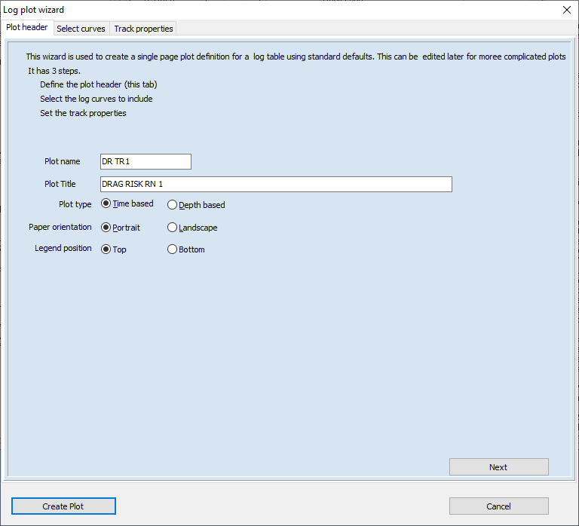

The second step is to add the curves. This is done via a dual list with the available curves on the left and the selected curves on the right.

Curves are added sequentially in groups corresponding to the tracks they appear in. They can be selected singly or in groups in the left list and moved to the right list with the [>] button or just double clicked to moved them from one list to the other. The [New track] button is used to insert a new track line in the right hand list.

The track format can be quickly defined by a series of double clicks to add curves and then a new track added when required.

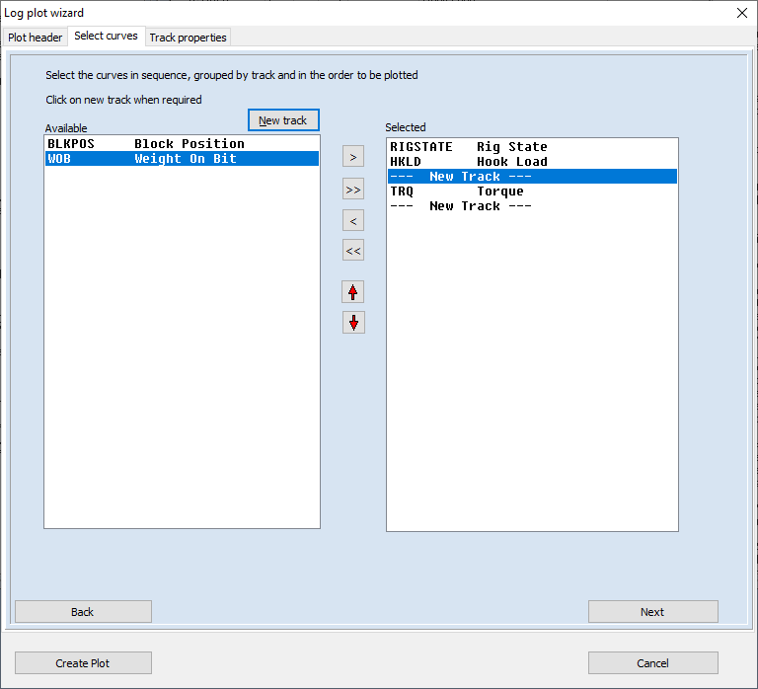

The red up and down arrows allow selections in the right list to be moved to new positions.

The 3rd step is to add the tracks. The curve list will be scanned and a track added for each track defined in that list.

Initially the left and right % positions will not be defined but by defining a gap as a % (usually 1 or 0 % of the plot width), a click on a button will set them all to the same width.

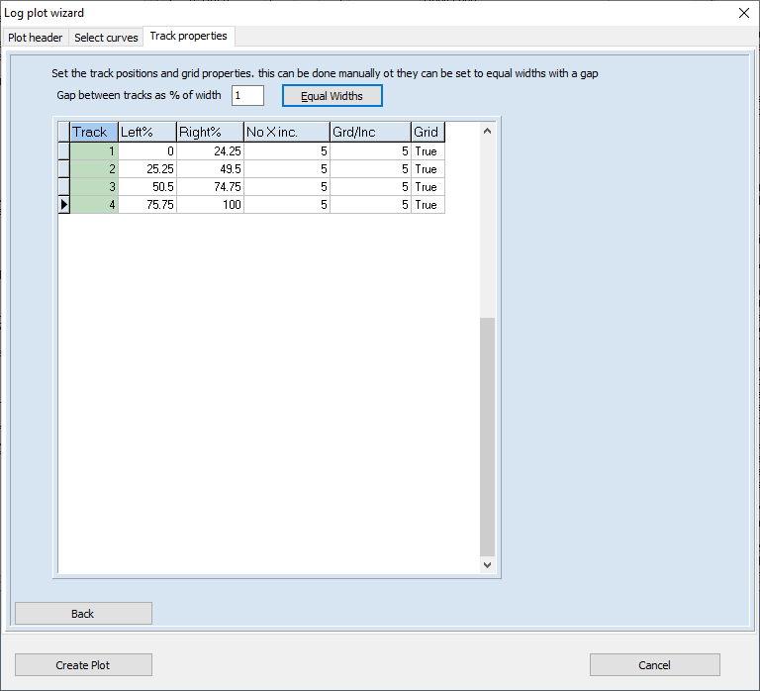

The plot can then be created. A warning will be given before overwriting an existing plot with the same name. Default line styles and colours are used but these can be changed later in the Log plot option.

# Log Plot definition

The plots created by the wizard are viewed in the Log Plots option

This has 3 tables – the top one is the plot list, the bottom left defines the tracks and their positions and the bottom right the curves, their appearance and the track they appear in.

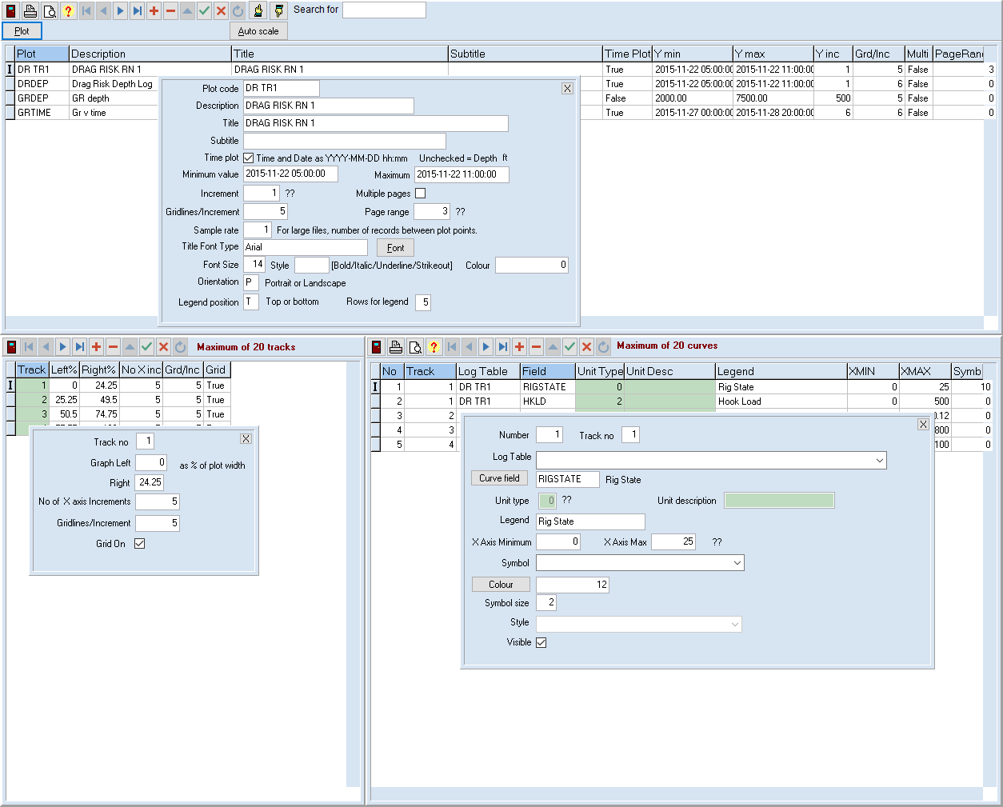

Like depth plots, the maximum and minimum for the X and Y values can be auto scaled by entering values of -999. However, unlike depth plots the increment in the X axis is not defined as a value but as the number of increments across a log track. Each log will display its start and end values only.

# Plot screen

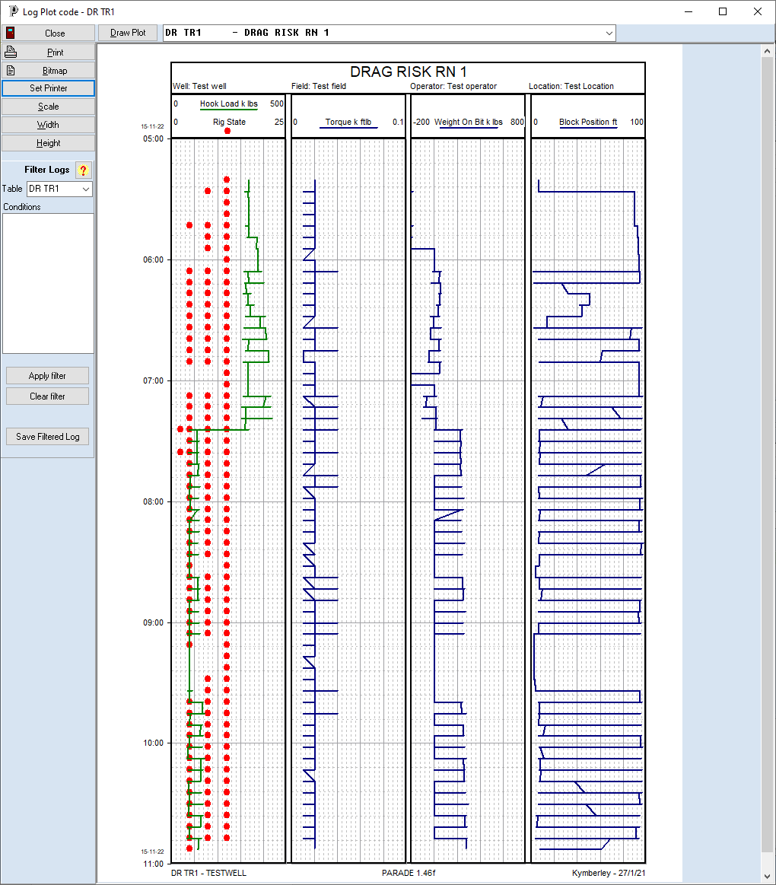

Logs are drawn in tracks with each track having a legend at the top or bottom for each curve. This gives the curve description, its appearance and its start and end values. Tracks may have curves with different units and different ranges so the grids are not labelled. The Y axis will display time or depth. If it is time based, the date will be displayed above the first and last time and whenever it changes.



The [Draw Plot] button and the dropdown combo box along the top allow a different plot to be displayed or the current plot to be redrawn.

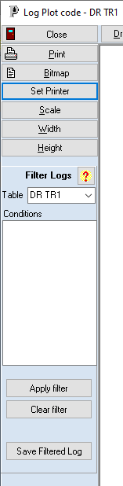The left panel has a number of buttons and panels.

Close – close plot

Print – print plot on currently selected printer

Bitmap – save plot as a graphics file (BMP, JPG or PNG) or to the clipboard for pasting to another document.

Scale – change plot parameters, grid properties.

Width – draw plot so that it fills width of plotting area

Height – draw plot so that it fills height of plotting area

## Filtering logs

The [?] button displays a pop up form that explains how filters work. This is the text:

Filters are a combination of conditions that must be true or false

A condition is a comparison between expressions consisting of field values and/or numbers

Field1>100

Field2+Field3<=2*Field4 +50

(Actual field names would replace "Field1" etc.)

These conditions can be combined using "and", "or" or "not"

Combinations of conditions should be enclosed in brackets.

( Field1>100 and Field1<200) or Field3<=Field4

The filters are applied to all curves displayed from the selected log table.

Most commonly there is only one table per plot.

Once applied, the plot is redrawn showing only points that match the filter

The filtered log can be saved as a new log table or to overwrite an existing log table.

Since a plot can display data from several tables the filtered table is selected, but in most cases there is only one table used so this is automatically selected.

The conditions are then entered as a combination of true false expressions involving field names and numbers.

This filter can be turned on or off. After each change the plot is redrawn.

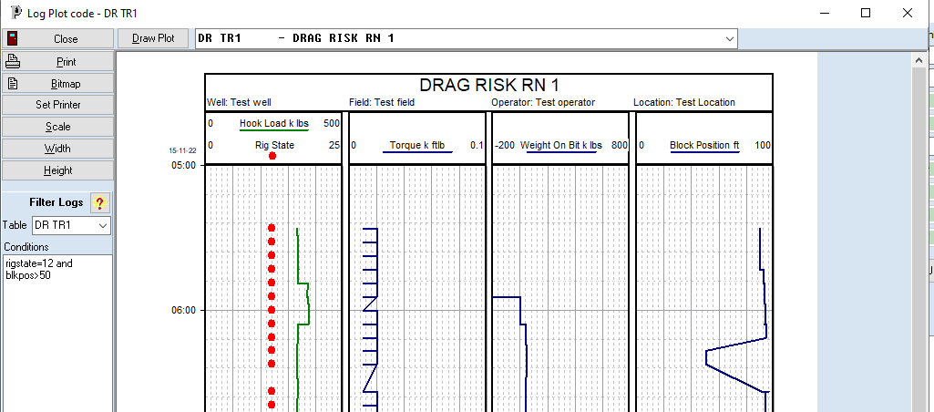

The filtered log can be saved as a new log. If it does not exist, it will be created with the same fields as the original log. The new code and description are entered, with defaults used.

## Scaling plots

The scale button displays the scaling dialog

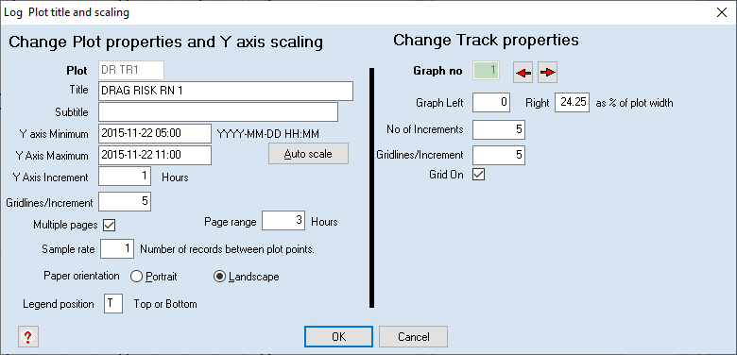

This allows changes to the plot title and Y axis range, the grid properties and orientation and to change between single and multiple pages.

Each track can have its width and grid properties changed.

Note that the filter may need to be applied again after changing scale.

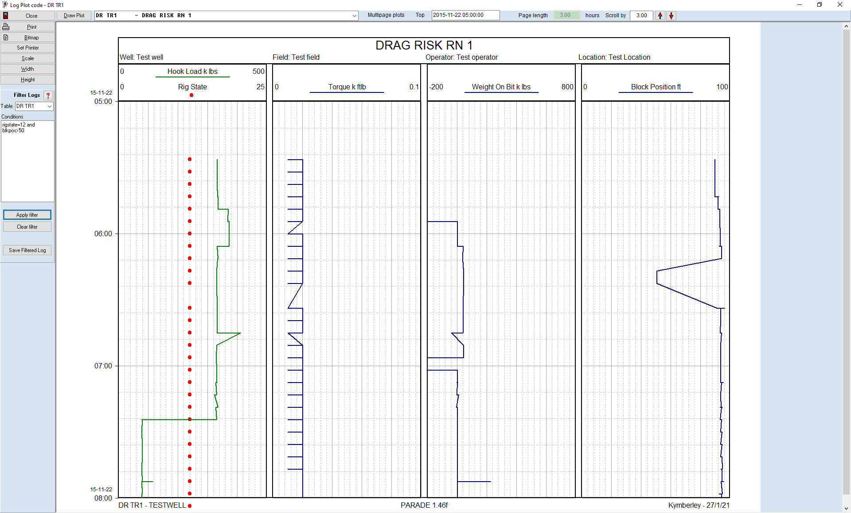

## Multiple page plots

For a multipage plot an additional panel is visible to control page scrolling.



The top of the page is selected and the page length is fixed. Initially the scroll value will match the page length but you can make it smaller if an overlap of pages is required.

Click on the Red arrows will adjust the top value by the Scroll amount (either up or down) and redrawn the plot from the new top.

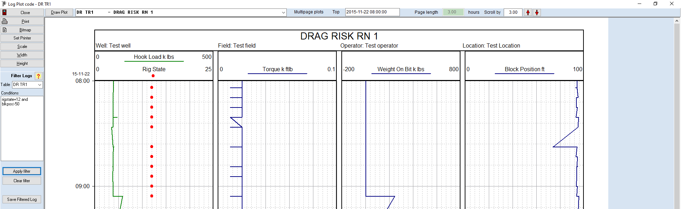

# Log data on Depth plots

Note that log data that is depth based can also be added to Depth plots. It usually has its own graph but can be overlaid on top of an existing track.

Logs in the same graph must come from the same log table and use the same units.

In this example, a depth based Gamma Ray log has been added to a Hook Load plot.

To create this from the standard Hookload plot requires a new graph for the Gamma ray

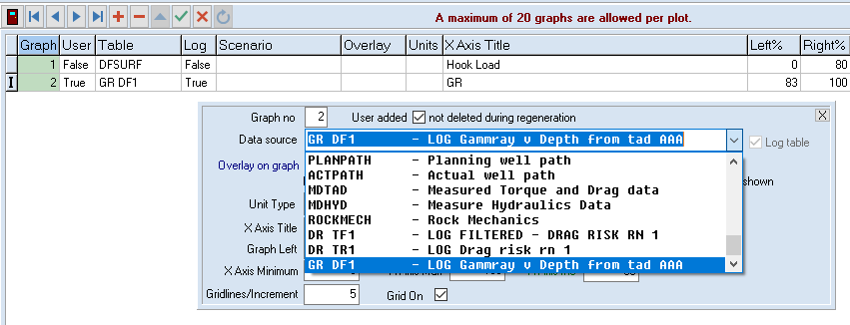In the Depth plot option select the plot and then add a new graph. Select the log file from the drop down. The log files are at the bottom of the data source drop down list The Log table check box will automatically be set.

The left and right % for the original graph and the new graph will need to be set, if the GR is not to be plotted on top of the hookload

Initially the minimum, maximum and increment for the GR graph can all be set to -999 to autoscale. Since GR has fixed units set the unit type to 0 for integer values or -1, -2 etc for 1 , 2 or more decimal places..

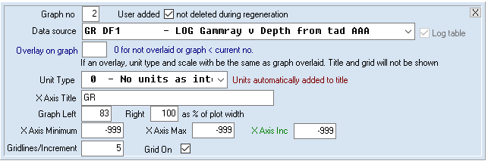

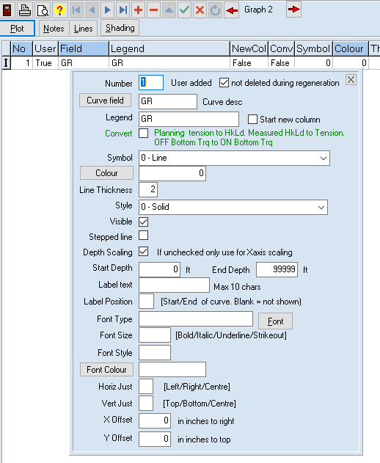Then click on [Curves] and add the GR curve to that graph.

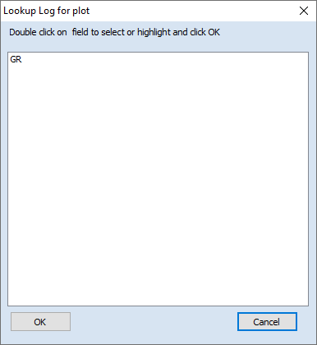Clicking on the [Curve field] button will display a list of curves from the log file with matching units.

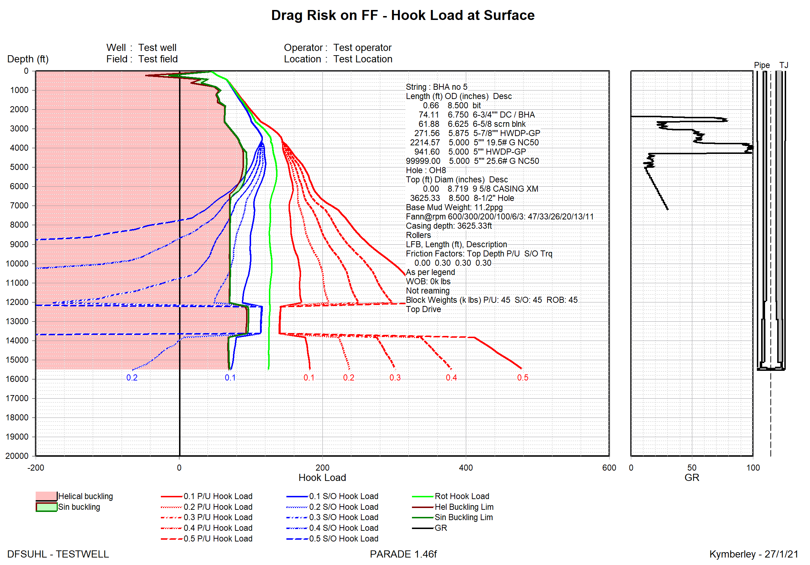

# Manipulating data

Often the data is what is termed raw data. Ie straight from the measuring device such a PWD or LWD. As such is may have a value every few seconds or every few centimetres. Such values are likely to be repetitive and may take some time to display or plot.

A filter can be applied to the table which will select some of the records and hide others. The filtered data can then be saved to a new file (or overwrite and existing one). This process can also be done in the plot and it is described earlier in this document.

An alternative speed up for plotting is to set the plot frequency, which is the number of actual records between points plotted. A sample rate of 10 would plot a point, skip to the tenth value after that to plot the next point and so on. This method will speed up plots at the cost of potentially losing some detail. A value of 1 will plot all points.

Plots can also be sampled. This process considers a number of points within each log curve based on a time interval or depth interval. For each interval the average, minimum or maximum value can be used to represent the group of points as a single point in the sampled log.

The Sampling process also allows unwanted spikes and noise to be eliminated and a filter can also be applied.

## The difference between sampling and filtering

Sampling is an attempt to reduce the number of points while retaining the basic shape of the curves (after removing noise). All points in the curve contribute to the sampled value.

Sampling is carried out on each curve individually, with the sampling function and parameters defined for each curve.

Filtering is an attempt to extract a subset of points which meet certain criteria. This may lead to a different shape to the curves.

Filtering selects records which match the criteria and takes the actual values of selected records for all curves.

# Sampling Log data

A sampled log is a new table created from an existing table.

In the Log tables option the source log is selected and opened. In the log details screen the [Create Sampled Log] button displays the sampling dialog.

Once a Sample log is created, the dialog must be closed then the source log details screen, before the new log can be viewed or a plot created.

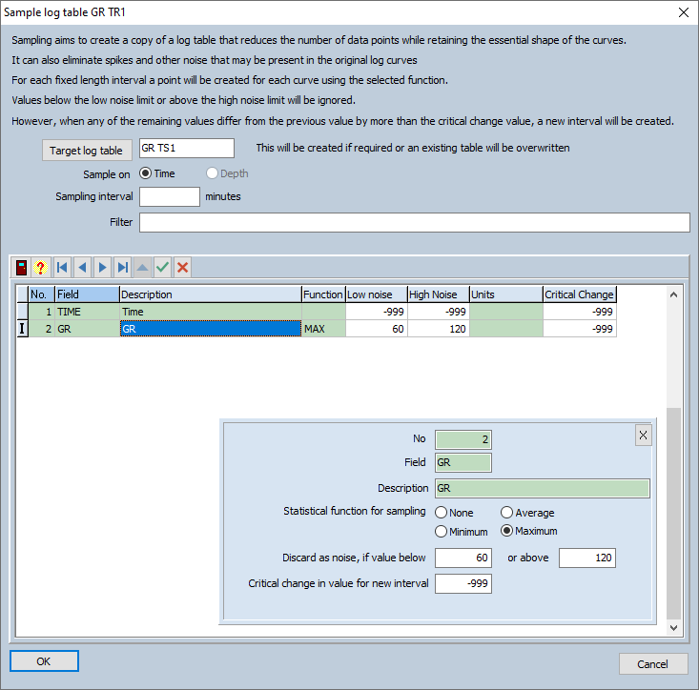

The target log table name must be entered and be different from the source. If the standard convention is used the name is created by replacing the R or F character in the source log name with S for sampled.

The sample field is Time or Depth and usually there will only be one, preselected choice.

For time, the sampling interval is defined in minutes and for depth, in the current depth units

A filter can be applied to the source curve before sampling begins.

Each curve/field in the log table has its sampling function and noise levels set separately.

Any values for the key field – Time or Depth are ignored.

The choices for sampling function are the average, minim or maximum value of the curve in the sampling interval. If None is selected, that curve will not have any values in the sample log file.

Many log curves have spikes or noise and these points can be eliminated for each curve by setting a low and high noise level. Only values that fall between these values are sampled.

Click OK to create the new log file.

Here is a plot of a Gamma Ray with curves sampled using each of the functions. Noise levels of 60 and 120 were applied. The sampling interval was 5 minutes

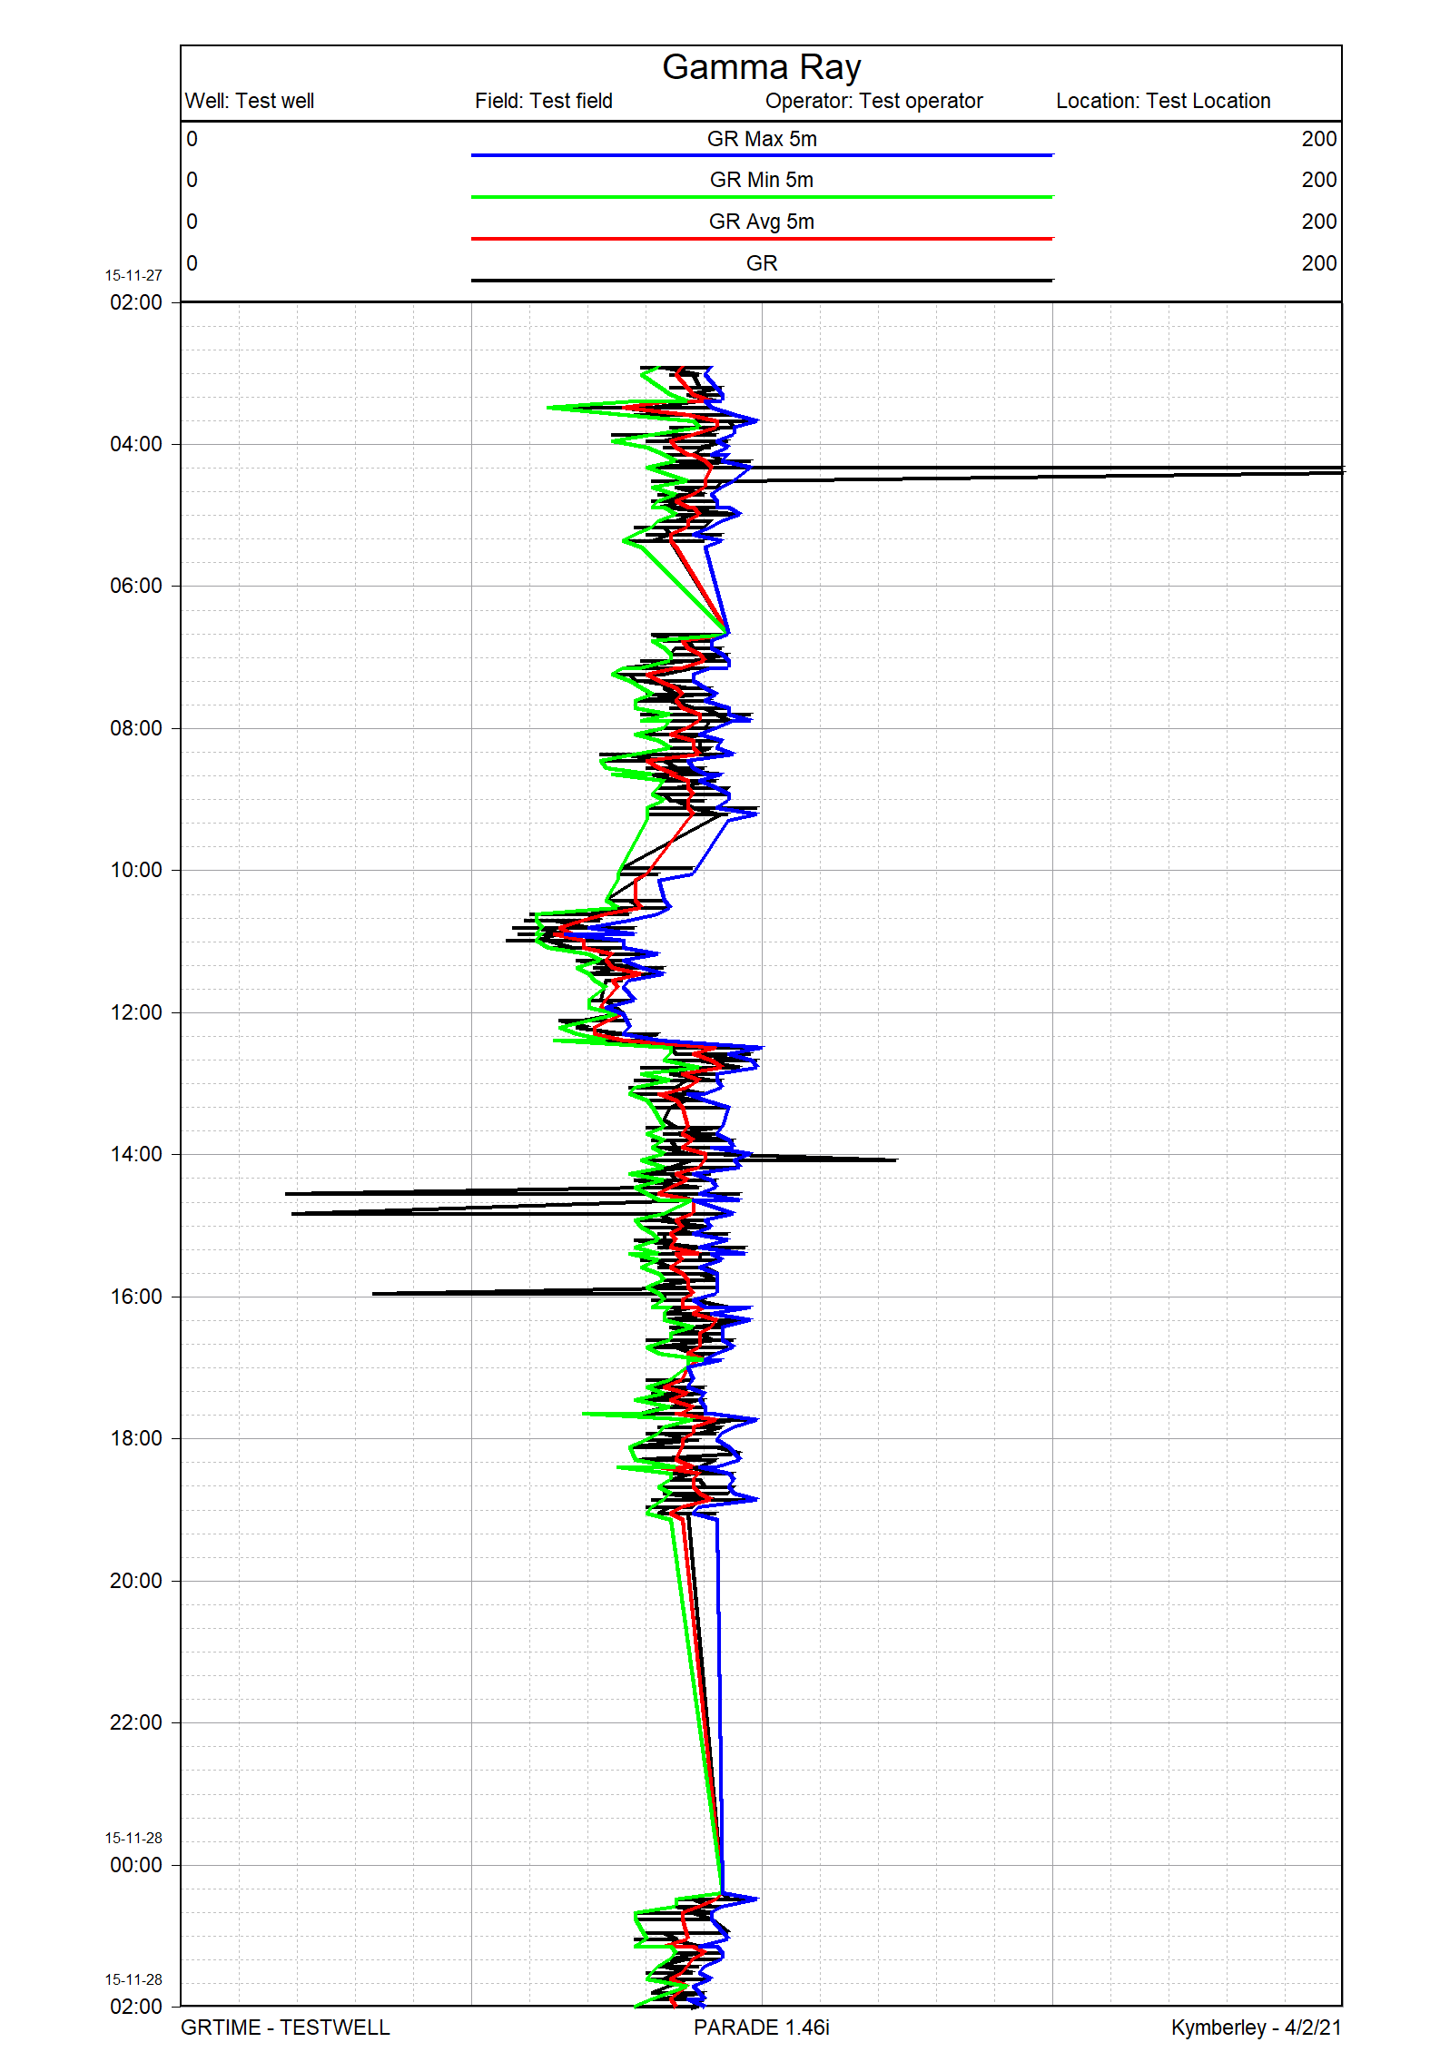

# Log Calculations

The calculation option allows a new log field to be created based on values in the existing log fields.

Click on the [Calculations] button in the Log details screen to display the dialog.

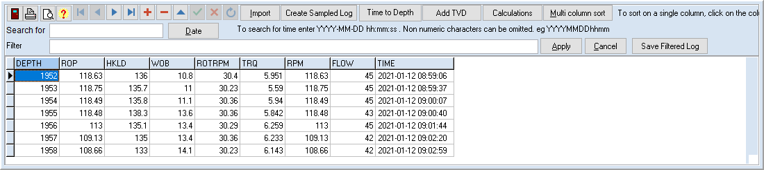

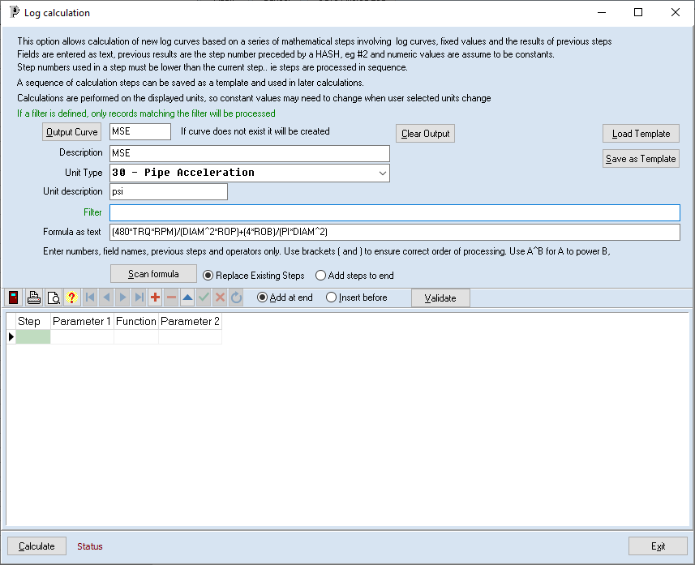

The output log details must be entered with the option to select and existing field by clicking on [Output Curve].

The Name, Description and Units for the output curve must be defined.

It may be a requirement that the calculations by only applied to certain records in the log table. Hence a filter can be applied to limited the records processed.

For example, differential pressure uses a reference pressure value that applies for a particular depth range and which may change in other depth ranges. By setting a filter on depth, a constant can be entered for the reference pressure applicable to each range.

Then a series of steps can be defined in the table.

Steps have sequential, integer values and hence before a new step is added the choice between adding at the end or inserting before the current step must be selected.

If a step is inserted, the step numbers for steps from the current step to the end are increased by one and the new step uses the number of the current step. In addition, any parameters that reference the current or later steps are also increased by one.

Similarly, when a step is deleted, later step numbers are decreased and references to those later steps also adjusted. However, if the step to be deleted is a parameter in a later step, then the deletion is not allowed.

Each step has this automatically maintained step number, a function and 2 parameters.

The function can be one of the following:

* ADD - Add 2 values (a+b)
* SUB - Subtract second value from first (a-b)
* MUL - Multiply 2 values (a*b)
* DIV - Divide first value by second (a/b)
* PWR - Raise first value to power of second value (a^b)

Note that when selecting a function from the dropdown combo box, only the first letter needs to be entered, ie A,S,M,D or P, to select the function.

The 2 parameters can be one of the following:

* The results of a previous step indicated by the hash character and the step number, eg #1
* The value of an existing field. Enter field name, eg RPM
* A numeric value. Eg 3.14159

Hence, quite complicated calculations can be performed by a series of steps involving 2 parameters each.

For example. The MSE equation is based on Torque (TRQ), RPM, Hole Diam (DIAM), ROP and Weight on bit (WOB), in oil field units, is

MSE = 480*TRQ*RPM + 4* WOB  
 DIAM2*ROP *DIAM2

or as a single line text expression

MSE=(480*TRQ*RPM)/(DIAM^2*ROP)+(4*WOB)/(PI*DIAM^2)

If the right hand side of that equation is entered into the formula field and [Scan formula] is clicked, the steps matching that formula will be created.

The order of processing follows the BEDMAS formula – Brackets, Exponents (ie powers), Division, Multiplication, Addition and Subtraction, so use of brackets is recommended. If the same operation appears more than once it is processed from left to right.

eg

1+3/4 = 1+(3/4) =1.75 but (1+3)/4=1

3/4*2 = (3/4)*2 = 1.5 but 3/(4*2) = 3/8 = 0.325 or 3/4/2=0.75/2 = 0.325

9/3*5/2 = (9/3)*(5/2) = 7.5 but 9/(3*5)/2= (9/15)/2 = 0.6/2 = 0.3

9^1/2 = (9^1)/2 = 4.5 but 9^(1/2)= 3

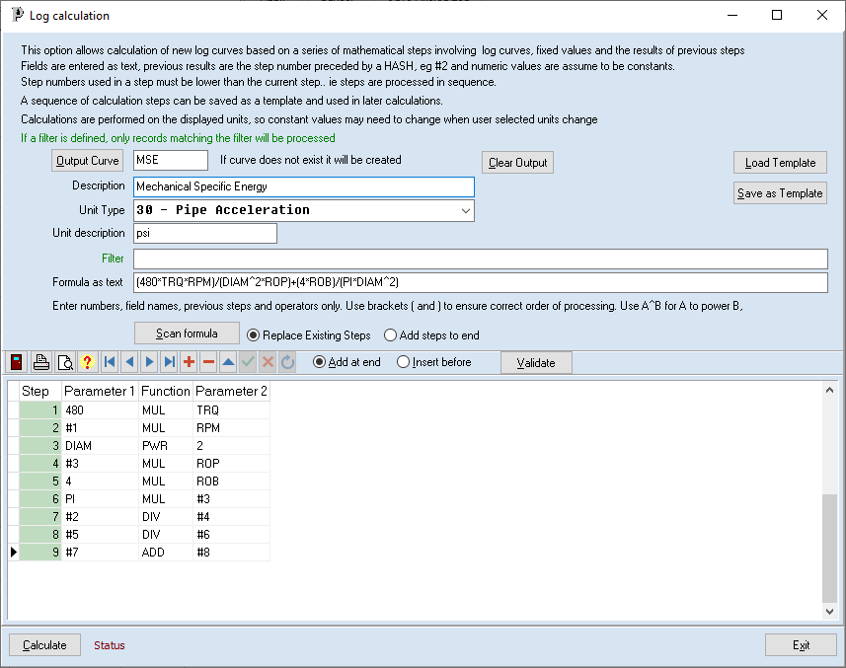

The formula is interpreted in stages and after each operation is expressed as a step, its sub string in the formula is replaced by the step number.

|  |  |  |  |  |
| --- | --- | --- | --- | --- |
| Formula | Step | Par1 | Function | Par2 |
| (480*TRQ*RPM)/(DIAM^2*ROP)+(4*WOB)/(PI*DIAM^2) | 1 | 480 | MUL | TRQ |
| (#1*RPM)/(DIAM^2*ROP)+(4*WOB)/(PI*DIAM^2) | 2 | #1 | MUL | RPM |
| #2/(DIAM^2*ROP)+(4*WOB)/(PI*DIAM^2) | 3 | DIAM | PWR | 2 |
| #2/(#3*ROP)+(4*WOB)/(PI*DIAM^2) | 4 | #3 | MUL | ROP |
| #2/#4+(4*WOB)/(PI*DIAM^2) | 5 | 4 | MUL | WOB |
| #2/#4+#5/(PI*DIAM^2) | 6 | PI | MUL | #3 |
| #2/#4+#5/#6 | 7 | #2 | DIV | #4 |
| #7+#5/#6 | 8 | #5 | DIV | #6 |
| #7+#8 | 9 | #7 | ADD | #8 |

Note: in step 6 the expression DIAM^2 has already been calculated in step 3

Click on validate to check for any errors.

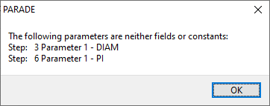

In this case, there is no DIAM field, so a fixed value of 6.5” is used rather than a field in the table. In addition, a value for PI should be entered as a number.

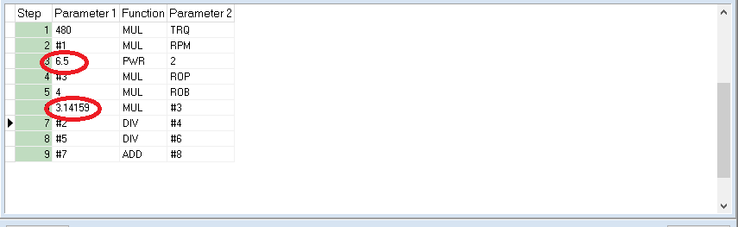

Once a set of steps has been created, it can be saved, together with the output curve definition as a template for future use. The next time the same calculation is performed, it can be loaded from the saved template.

When a template is loaded it checks that the fields used in the steps exist in the log table being processed and gives a warning of any that are missing.

## Calculation units

WARNINGS:

* All calculations are performed in the selected user units.
* Constants used in a formula may need to be changed, depending on the units used.

For example, in the hydraulics calculations Pressure (psi) and TVD (ft) are used to calculate ECD (ppg) using

ECD:= Pressure/(0.052*TVD)

The 0.052 constant would need to change for different units, eg Bar, m and KG/m3.

When a template is saved, the user units are also saved. When it is loaded, a warning will be given if units are different. The user will need to adjust the constants where necessary for the new units, It is recommended that where this may happen, different templates are created for different sets of units.

## Running the calculation

When the [Calculate] button is clicked, validation tests are run and if they fail a message will be displayed and the calculation will not occur.

If the output curve does not already exist in the log table, it will be created. If it does exist a warning that its values will be overwritten will be displayed.

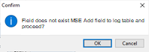 or 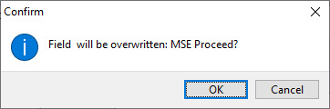

Once the calculation is complete and the dialog closed, the log will be redisplayed with the calculated curve included or updated.

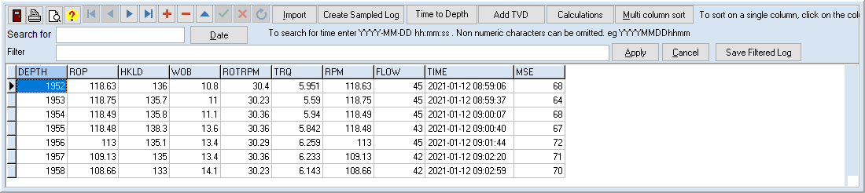

The calculated curves can be plotted along with the original curves.

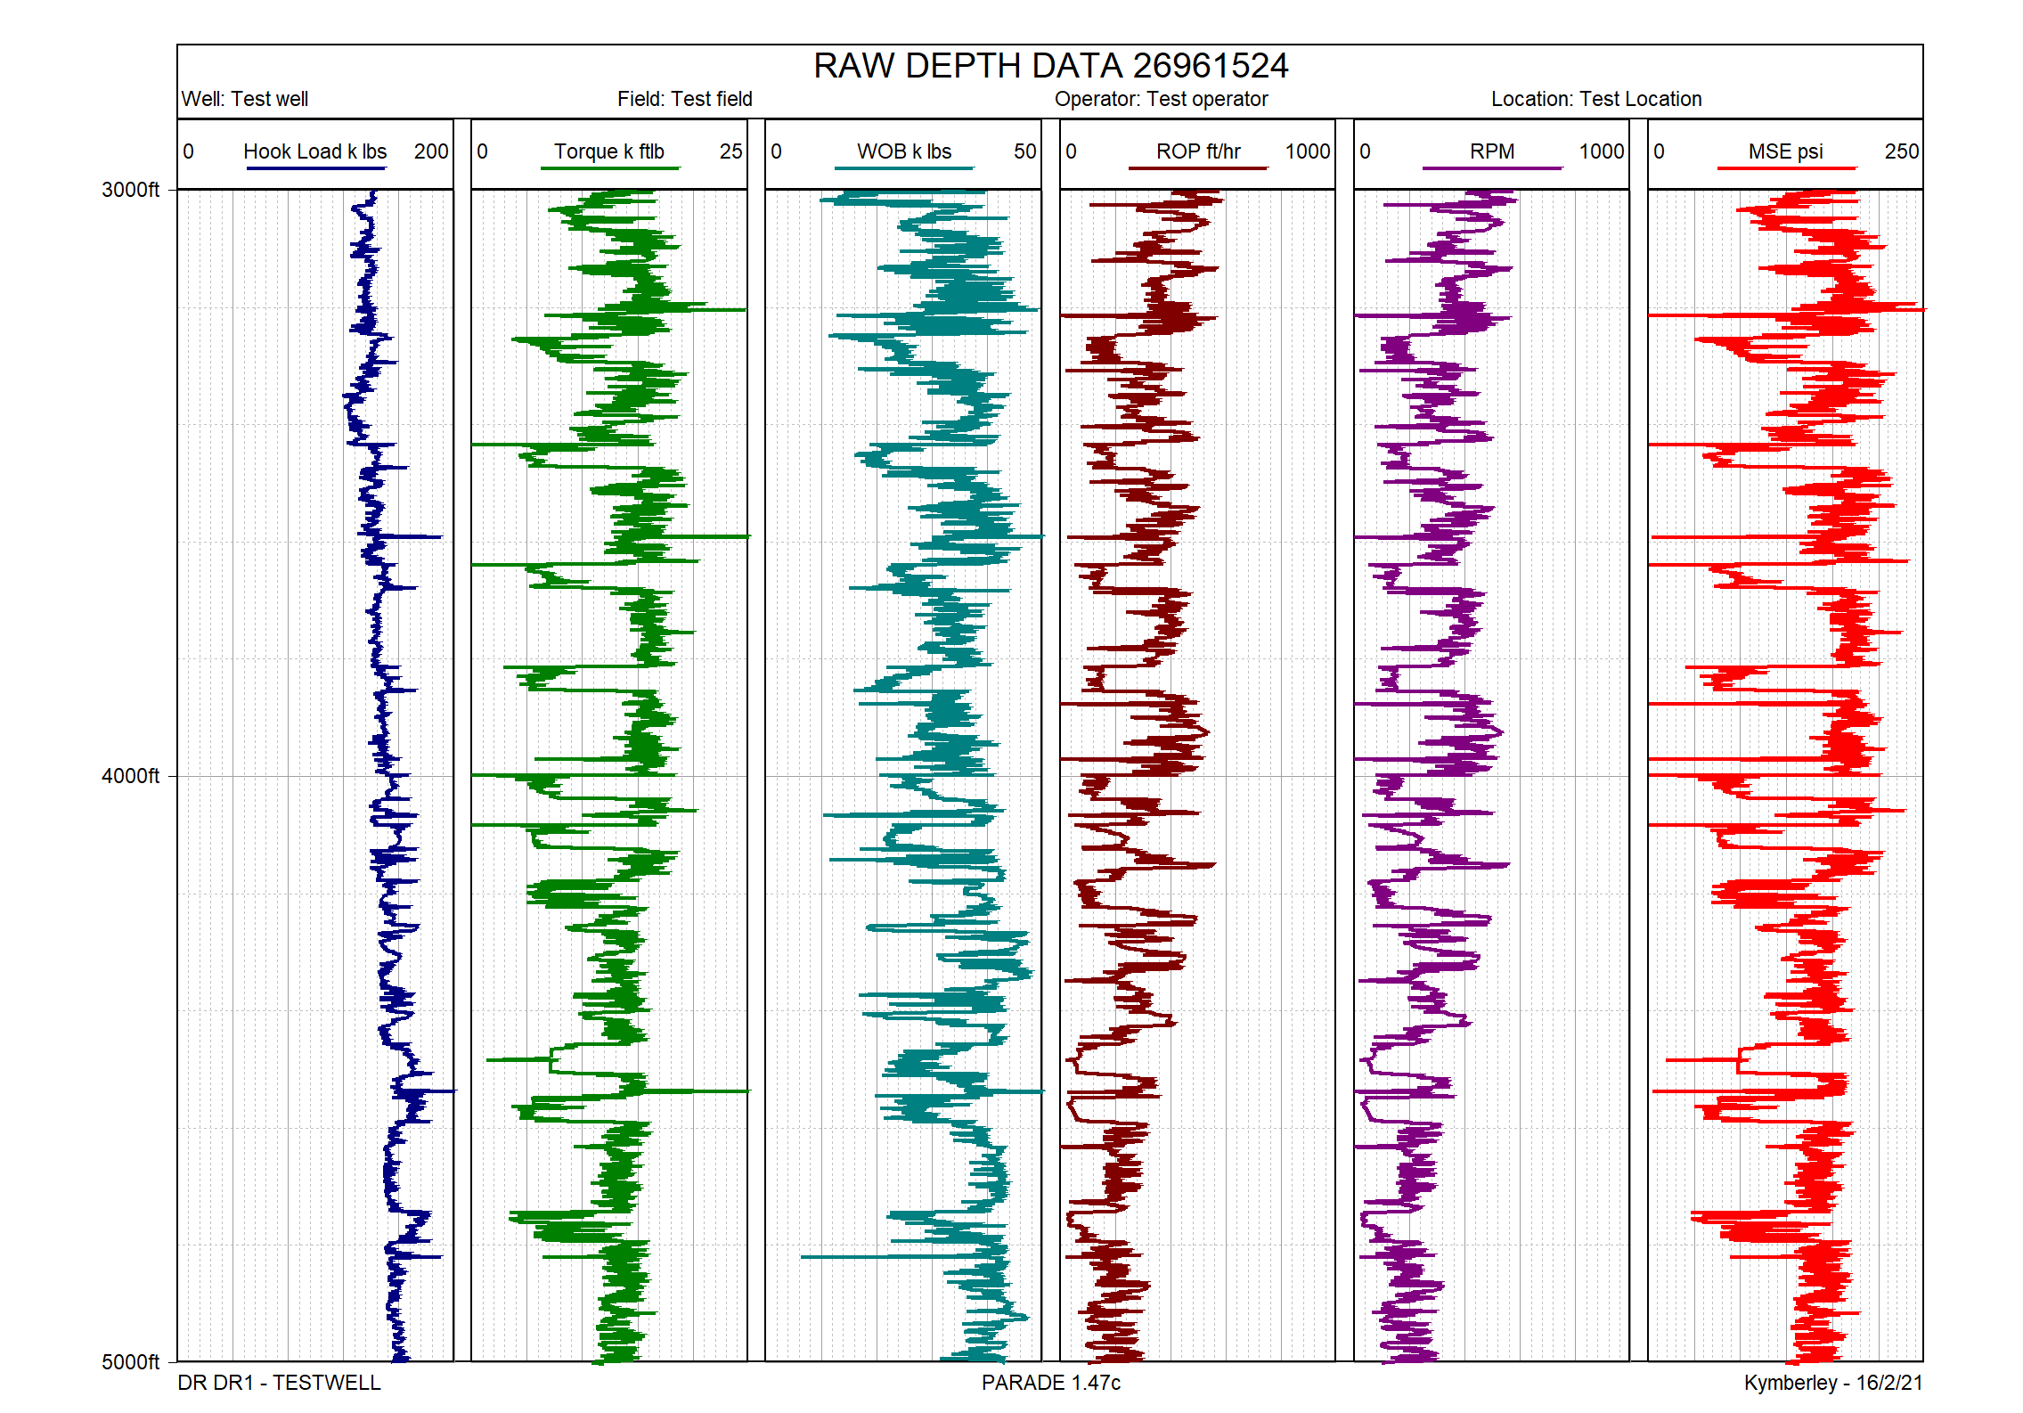

## Differential pressure calculation

Differential pressure is simply the difference between a measured pressure and a reference pressure. However, the reference pressure may change from time to time

To calculate this, create a calculate with output field, eg DIFFPRESS, and 1 step

The step embodies the formula PRESS-REFPRESS. However rather than a REFPRESS field an actual value is entered. This step, combined with a filter based on depth would calculate the Differential pressure over the depth range where the entered reference pressure applies.

The value of the reference pressure and the depth range are then changed and the calculation run again. Repeat this for each reference pressure range.

Log Export

Click on the [Export] button to export the data to a tab delimited text file. If a filter is applied, only the filtered records will be exported.

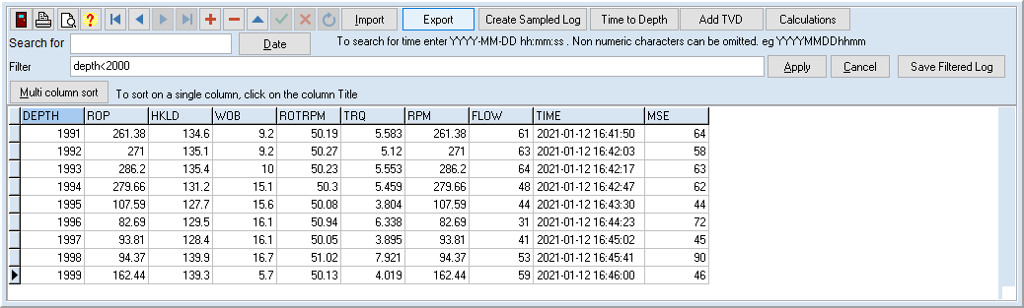

A dual list dialog appears with all records selected, in the order of definition for the table.

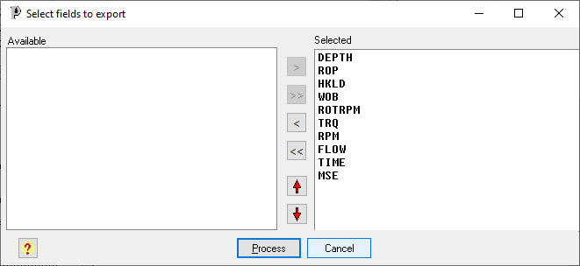

If not required, a field can be removed from the selected list by double clicking on it.

Click [Process] and a file save dialog appears with a default file name of the table name+’-export.txt’.

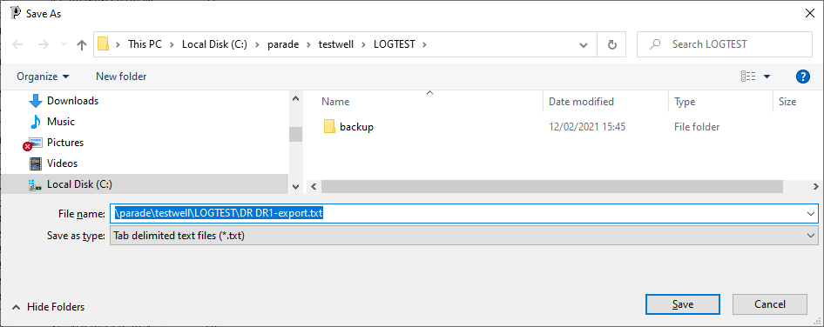

The select records and fields will be saved to that text file. The file will include a line with the field names and a line with the unit description for each field, followed by the data.

The file can be viewed in a text editor or Excel

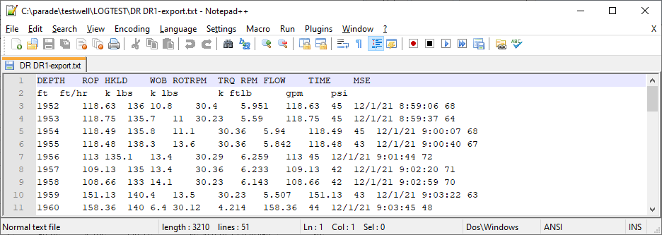

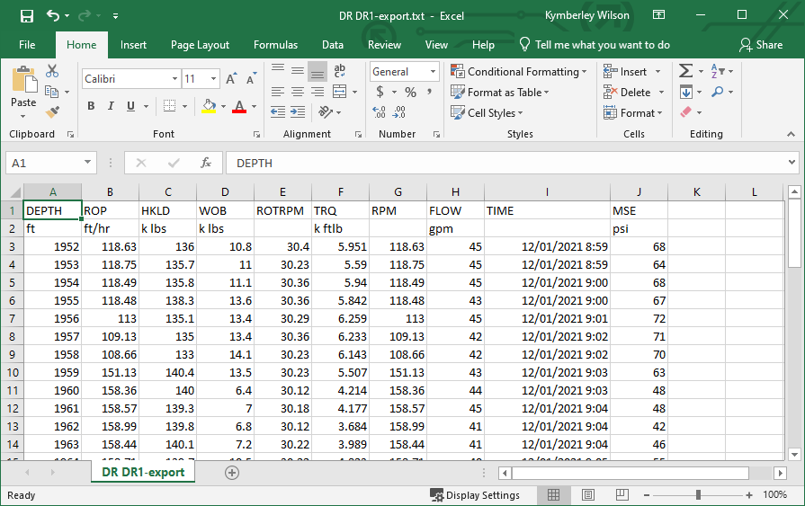

# Log Import Formats

The log import screen requires the definition or the text file type, the first line to import, the time and date format and the display width when expanding Tab or csv files. It also required the position within the line of each field imported.

Once such values have been defined they can be saved to a template library and reused next time the same format file is processed.

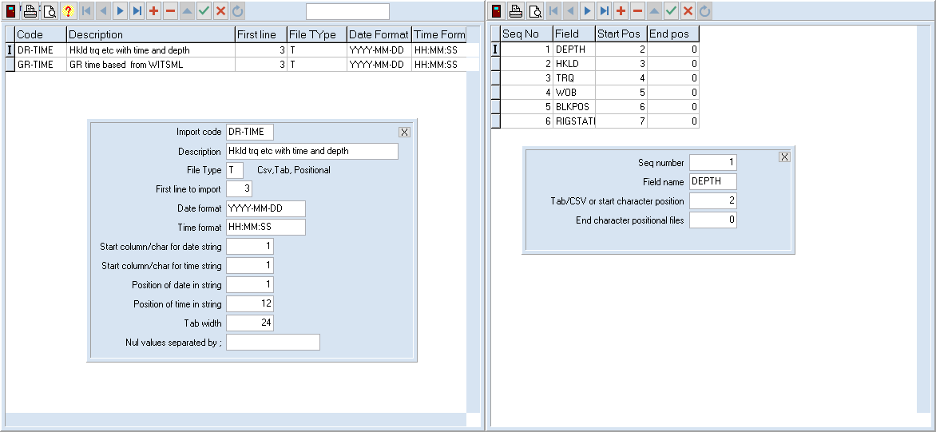

The left table lists the templates that have been defined plus the values of the parameters.

The right table defines the fields to be imported and their positions on the line. For Tab and CSV files this is the columns number and for positional/plain text files it is the first and last character for the field.

Note that some files that are to be imported may have a single column for date and time. In this case the same Start column would be used but a different start character when interpreting the text.

In other files, each of these may have its own column.

Parade will import the data and time based on these parameters and then combine them to a single DateTime value. This should be defined as Field Time and type T in the log tab

# Log definition templates

Each log table used must have its fields defined. Once a log table is defined the fields can be saved to the library as a template for later use, when the same data is imported again for a different run or well.

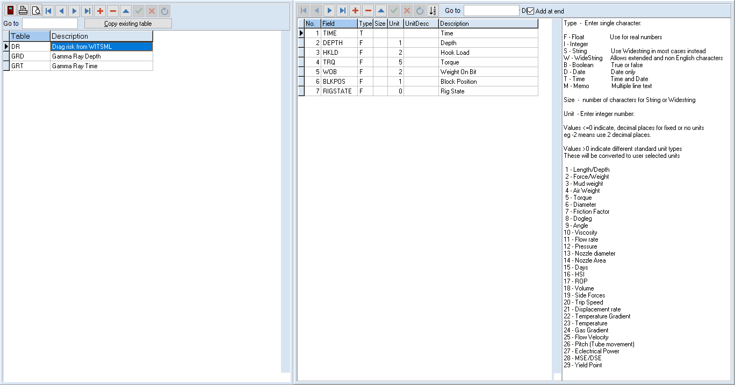The left table list the field templates and the right table the fields for the selected template.

Each field has a name, data type as per list on the right and unit type, also described on right.

For curves with fixed units or no units, the number of decimal places for the display can be entered as a negative number. In this case the unit description can also be entered.

Usually these fields will be defined for an actual log table rather than in this option.

The [Copy existing table] button allows that field definition to be imported for reuse

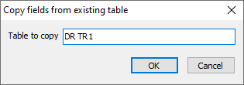

# Log Calculation templates

This option on the log menu allows the Calculation templates to be viewed.

The left table lists the calculation templates and the right table lists the steps in the selected table.

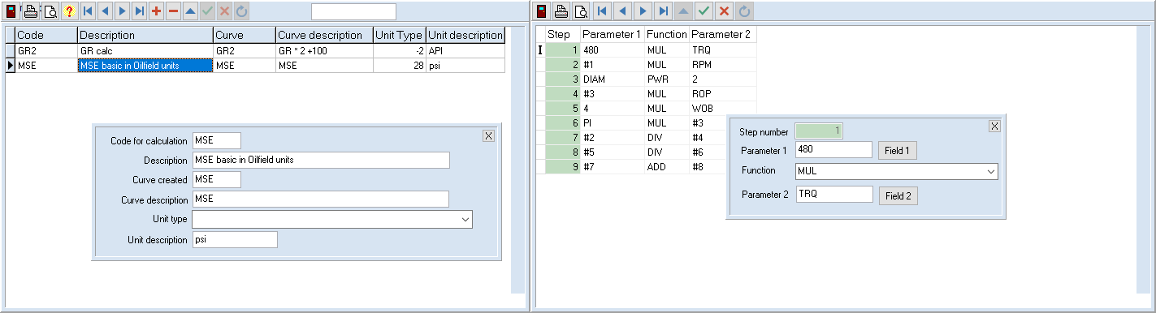

Unlike the table of calculation steps in the log calculation dialog, it is not possible to add or delete steps.

Only the parameter values or function type can be corrected.